PETROLEUM SAFETY TASK FORCE
Petrol Stations Inspection
& Compliance Visitation to the Storage Terminals for Tongatapu
Department of Energy Report 2024

This Task Force was implemented by the Ministry of Trade and Economic Development (MTED) in 2021. Made up of relevant Government Departments from Line Ministries to carry out safety inspections of individual Petrol Stations (Service Stations) and the Petroleum Terminals at Touliki to ensure compliance with health, safety, and environmental concerns for the safety of the service providers and the public at large. This is the second year the Department of Energy has participated and has been a good opportunity for the Team involved to get a first-hand experience on the situation on the ground, especially regarding the Petroleum Sector. The inspections for Tongatapu were carried out from the 28th of October to the 1st of November 2024.

Team from the Energy Department.
Mr. Filimone Fifita – Energy Officer
Mr. Vilipalu Taufalele – Energy Technician
Mrs. ‘Asela Taufa – ICAT Project (Land and Road Transport Officer)

Inspection Checklist (Energy Department)
- Emergency procedure for fire, spoilage, accidents, and equipment failure
- Spills kits and first aid must be at the Gas Station
- List of emergency contact numbers that include, fire department, ambulance, and the police displayed
- The main emergency switch should be accessible
- Site plan and Risk Assessment

Service Station Inspection for Tongatapu

No. | Service Station | Findings
1 | Cocker Enterprises (Chinese Owned)  Location: Ma’ufanga  Supplier: Total Energies Ltd | - Emergency procedures for fire, accidents, spillage, and equipment failure but very minimal  - No training for employees  - No spill kit  - No first aid kit  - Only emergency numbers for fire emergencies are displayed  - No site plan  - Both petrol pumps have an emergency switch  - No site plan  - Main switch is accessible
2 | Discoveries Cooperation Ltd  Location: Ma’ufanga  Supplier: Pacific Energy | - No spill kit  - No first aid kit  - No site plan  - No emergency numbers displayed  - No training for employees  - Broken switch (GPO) faulty exposed wiring (4ft Light)  - The service station employee had young children present with her, this is a major safety concern.  - Main switch is accessible
3 | Luna’eva  Location: Pahu  Supplier (Pacific Energy) | - No spill kit  - No first aid kit  - No site plan  - No emergency numbers displayed  - No training for employees  - Main switch is accessible
4 | Cocker Enterprises  Location: Hala Fatafehi Kolofo’ou  Supplier: Total Energies Ltd | - No spill kit  - No first aid kit  - No site plan  - No emergency numbers displayed  - No training for employees  - Main is accessible  - Two employees
5 | Asco Motors  Location: Mailetaha  Supplier: Pacific Energy | - Fire Drills carried out yearly  - First Aid Kit available inside Office  - Site plan clearly displayed  - No emergency numbers clearly displayed  - No spill kit  - No trainings for employees  - Main switch is accessible
6 | EM Jones  Location: Kolofo’ou  Supplier: Pacific Energy | - No spill kit  - No first aid kit  - No site plan  - No emergency numbers displayed  - No training for employees  - Main switch is accessible  - Both petrol pumps have an emergency switch
7 | Matavai Mo’ui Tevita Simote & Son  Location: Kolomotu’a  Supplier: Total Energies Ltd | - No spill kit  - No first aid kit  - No site plan  - No emergency numbers displayed  - No training for employees  - Main switch is accessible  - Both petrol pumps have an emergency switch  - Two employees
8 | Lisiate Rass  Location: Sopu  Supplier: Pacific Energy | - No spill kit  - No first aid kit  - No site plan  - No emergency numbers displayed  - No training for employees  - Main switch is accessible  - One Employee  - Only one of the Petrol Pumps have an emergency switch  - No smoke detector in cashier's office  - One of the petrol pumps is being supported by a piece of timber  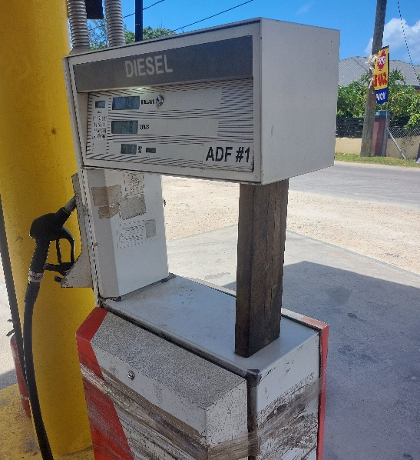
9 | Luna’eva  Location: Hala Hihifo  Supplier: Pacific Energy | - No spill kit  - No first aid kit  - No site plan  - No emergency numbers displayed  - No training for employees  - Main switch is accessible  - One of the petrol pumps is being supported by a piece of timber  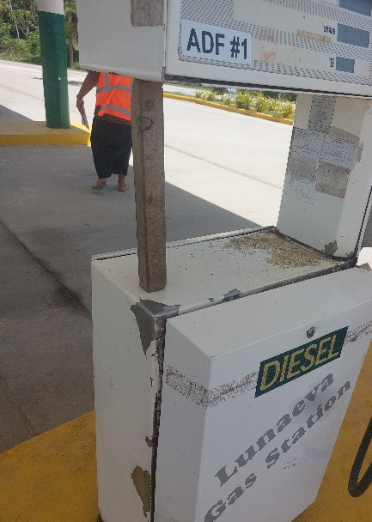
10 | M&J Company Gas Station  Location: Hofoa  Supplier: Total Energies Ltd | - No spill kit  - No first aid kit  - No site plan  - No emergency numbers displayed  - No training for employees  - This location is two separate businesses; the service station is owned by a separate owner from the shop  - The Main Switch is locked in a separate room beside the shop.
11 | Sia’atoutai  Supplier: Total Energies Ltd | - No spill kit  - No first aid kit  - No site plan  - No training for employees  - No smoke detector in cashier’s office  - One employee  - Main accessible  - No emergency numbers displayed
12 | Taniela Vaitohi  Location: Nukunuku  Supplier: Pacific Energy | - No spill kit  - No first aid kit  - No site plan  - No training for employees  - No smoke detector in cashier’s office  - One employee  - Main is accessible  - Only one of the Petrol Pumps have an emergency switch  - Unsafe electrical wire/ broken GPO  - No emergency numbers displayed
13 | Lotoma’a  Location: Kolovai  Supplier: Pacific Energy | - No spill kit  - No first aid kit  - No site plan  - No training for employees  - Main is accessible  - Old Petrol Pumps with no emergency switch  - Breaker needs to be replaced and replace old wirings  - No emergency numbers displayed
14 | Palu Trade  Location: Houma  Supplier: Pacific Energy | - No spill kit  - No first aid kit  - No site plan  - No training for employees  - Two employees  - Main switch is accessible  - Old Petrol pumps with no emergency switch  - Small shop located right next to the Service Station  - No emergency numbers displayed
15 | Konifelenisi  Location: Fanga  Supplier: Pacific Energy | - No spill kit  - No first aid kit  - No site plan  - No training for employees  - One employee  - Unsafe electrical wiring  - One old petrol pump  - No emergency numbers displayed  - Main switch is accessible
16 | EM Jones  Location: Koloua (Poutaha)  Pacific Energy | - No spill kit  - No first aid kit  - No site plan  - No training for employees  - Self Service  - Old petrol pumps with no emergency switch  - No emergency numbers displayed  - Main switch is accessible
17 | EM Jones  Location: Pea  Supplier Pacific Energy | - No spill kit  - No first aid kit  - No site plan  - No training for employees  - No emergency numbers displayed  - One Employee  - Fix mounting block outside (unsafe)  - Main switch is accessible  - Fire extinguishers need to be replaced
18 | Manu Family  Location: Tokomololo  Supplier: Pacific Energy | - No spill kit  - No first aid kit  - No site plan  - No emergency numbers displayed  - No training for employees  - Main switch is accessible  - 3 employees
19 | Lopaukamea  Location: ‘Atele  Supplier: Total | - No spill kit  - No first aid kit  - No site plan  - Only emergency numbers for fire emergencies are displayed  - No training for employees  - Main switch is accessible
20 | Luna’eva  Location: Veitongo  Supplier: Pacific Energy | - No spill kit  - No first aid kit  - No site plan  - No emergency numbers displayed  - No training for employees  - Main switch is accessible
21 | Palu Aviation Service  Location: Vaini  Supplier: Pacific Energy | - No spill kit  - No first aid kit  - No site plan  - No emergency numbers displayed  - No training for employees  - Main switch is accessible
22 | Palu Aviation Service  Location: Malapo  Supplier: Pacific Energy | - No spill kit  - No first aid kit  - No site plan  - No emergency numbers displayed  - No training for employees  - Main switch is accessible  - 5 employees
23 | Palu Aviation Service  Location: Fua’amotu  Supplier: Pacific Energy | - No spill kit  - No first aid kit  - No site plan  - No emergency numbers displayed  - No training for employees  - Main switch is accessible  - 2 employees
24 | Pausa Tatakamotonga  Location: Tatakamotonga  Supplier: Pacific Energy | - No spill kit  - No first aid kit  - No site plan  - No emergency numbers displayed  - No training for employees  - Main switch is accessible  - 4 employees
25 | Sione Galilee  Location: Lapaha  Supplier: Pacific Energy | - No spill kit  - No first aid kit  - No site plan  - No emergency numbers displayed  - No training for employees  - Main switch is accessible
26 | Liu Gas Station  Location: Manuka  Supplier: Pacific Energy | - No spill kit  - No first aid kit  - No site plan  - No emergency numbers displayed  - Basic safety training was done last year  - Main switch is accessible  - 5 employees

Issues that need to be addressed immediately

- Some service stations still operate the old petrol pumps; the newer upgrades have an emergency off switch. For safety reasons, all service stations should upgrade to the newer version.
- A lot of the fire extinguishers at the service stations either need to be refilled or replaced. This issue should be enforced to ensure that the service stations comply with basic safety standards.
- As mentioned above, one employee brought their young children to the service station. This should not be allowed, as it is a major safety risk.

Recommendations by the Department of Energy

The Department acknowledges the importance of this taskforce and is willing to continue participating in these inspection activity moving forward. It is obvious that the basic safety practices at these service stations are severely lacking. The department recommends that the reports from this taskforce should be circulated to the service stations so attempts could be made to improve safety and standards therefore in the future inspections we can be able to gauge any improvements made by the service stations.
Training of service station employees is a challenge as the people employed are usually on a short term basis. Rarely an employee at these service stations last more than two years let alone a full year. However, the service stations should provide basic things like displaying emergency contact numbers, having spill kits available and an evacuation site plan.
Finally, the Department proposes developing a Code of Practices for the following.
- Standards for designing and constructing services stations
- Petroleum storage and transport
- Products handling
- Storage and handling
- Protection from fire hazards
- Safety management documentation
- Weights and Measures standards for dispensing petroleum products
- Health and Safety for employees
- Training programs
- Ensuring customer safety
- Potential theft awareness
- Safe driving measures
- Assessment of harm
- Displaying the correct price for fuel

Safety Compliance Visit to the Storage Terminals for Tongatapu.

The task force conducted special training before continuing to inspect both Terminals. This included checking that each member had appropriate safety gear (shoes, shirt, trousers, helmet, glasses). Safety equipment is a must onsite, especially helmets that should be worn at all times except certain ‘green zone areas’ and these are marked. This introductory training is mandatory not only for employees at the site but for all visitors as well. No issues or concerns after the visit to both terminals.

Total Energies Terminal

Safety kits are provided inside the terminal, emergency routes in case of a fire, and exits are marked. Fire extinguishers are regularly checked and are readily available inside the compound. The compound is under strict security and the entering and exiting are monitored.

Pacific Energy Terminal

Fire extinguishers are checked and replaced every six months. Petroleum delivery vehicles to the airport are designed specifically for this purpose. Samples from the wells are tested every week to ensure no leaking.

